Business intelligence Purchasing
Project Initiation Document


Document History
Revisions
Version | Status | Date | Send
1 | Done | 05-01-2015
Approval

Version | Date approval | Name | Function | Sign-off
1
Distribution

Version | Date send | Name | Function

Index
Management summary 4
1.1 Purpose 4
2 Project definition 5
2.1 Project goals 5
2.2 Chosen solution 5
2.3 Products / End result 5
2.4 Boundaries 5
3 Project Organisation 6
3.1 Contractor 6
3.2 Project Leader 6
3.3 Business support 6
3.4 Technical support 6
4 Product Decomposition structure 7
4.1 Main Product: 7
Goal 7
Consistence 7
Sources 7
Quality Criteria 7
5 Planning 8

Management summary

Purpose
The purpose of the PID is to define the project, to form a firm basis for management and the assessment of overall success. Information included in the PID will answer the following questions:
- What is the project aiming to achieve?
- Why it is important to achieve it?
- Who will be involved and what are their responsibilities?
- How and when will it happen?
It is essential to obtain a clear view of the final objectives and outcome, as well as constraints and assumptions that impact on those responsible for the project. This document outlines all of the essentials to form a firm foundation for the project, including objectives, business benefits and risks, quality expectations, scope and timeframes.

Project definition

Project goals
There are many reports and evaluation processes for vendors already implemented in SAP. But they are not so obvious and easily reached by the managers. Furthermore, presenting all those information in a meaningful and memorable way is a hard task.
The goal of this project is to simplify the procedure and present information about the vendors with less effort and more reliability. By using a dashboard the managers will be able to evaluate, analyze and predict each vendor’s behavior from data that already exists in the system. Instead of getting deep familiarity with SAP in order to be able to generate all the usable and necessary reports, we offer a much simpler solution by using a dashboard to present all the information. The most important and used reports will be at hand, plus any billing documents needed.
Our big challenge is the retrieval of those information as well as the best and more practical way to present them. Retrieving the data from SAP will prove to be a trivial task. Moreover, as we ‘ve already seen there are various methods to present different data. Specific types of charts have to be used for presenting the information in the best possible way. Ex. On the credit report per month on a specific vendor the best way to present the data is by bar chart instead of pie.

Chosen solution
The solution we chose is a dashboard and by the ETL process we will extract all data needed for the reports and evaluation of the vendors. The dashboard will provide faster and better access in mandatory and useful reports

Products / End result
The end product of our project will be a dashboard with all the necessary reports to run day-to-day operations, as well as some statistical and summarizing reports. Ex. Credit of vendor per month, materials purchased per month, delivery times (in days) per material per month, delivery times per order per month etc.

Boundaries
The dashboard will be limited only by vendor. The user won’t have the ability to evaluate materials, material groups or any other category. Also, not all reports will be present. The use of the dashboard is focused on day-to-day reports that need to be generated, as well as for some monthly and quarterly reports. For comparing vendors or whole year reports managers will still be depended on SAP.
The reason of this drawback is the amount of reports available in SAP. Due to their numbers, our dashboard will be much more complicated both for us and the client, if we included all of them.

Project Organisation
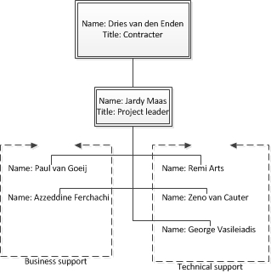

Contractor
Role: The customer that has a need for our product.
Responsibility: Accept the delivered products.
Tasks: Deliver his wishes to the team.

Project Leader
Role: Serve as a central point between the project team and the contractor and keeps track of the progress.
Responsibility: Deliver the products to the contractor and communicate between the different parties.
Tasks: Oversee the project.

Business support
Role: Team members with business knowledge.
Responsibility: Quality check of the business aspects.
Tasks: Take the lead in the business aspect of the assignments.

Technical support
Role: Team members with technical knowledge.
Responsibility: Quality check of the technical aspects.
Tasks: Take the lead in the technical aspect of the assignments.

Product Decomposition structure

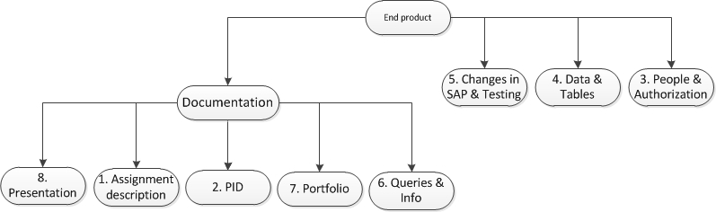
Product Description with name en number

Main Product:

Goal
We will deliver a product which can provide accurate information based on big amounts of data, which will help in making decisions at a strategic level (higher management) in the organization. In this case the focus lies on determining which suppliers are preferred above others.

This can be done by stating facts of certain products. We will determine which suppliers or vendors fits best for which products. This is determined on trustworthiness, prices, and delivery times and so on. We can subtract that data from the current SAP-system, which has all the purchase orders for all the different products. Based on that data we want to provide information which will help management to run the organization more efficiently, and save them money and time in the delivery of products.

Though we deliver the information it’s up to the management to decide what to do with that information. Whether they make a decision to take a certain supplier or not, is not up to us. We only provide the necessary information to make that decision. How this is done technically will be specified later in the project.

Consistence
The end product is a new process build in SAP that analyses the suppliers in order to make some preferred suppliers. This is show in SAP when users are able to choose a supplier for the material(s) they want to buy.

Sources
The data we use to analyze we get from the customer.

Quality Criteria
The analyzed data must be shown clearly in SAP. The preferred suppliers must be highlighted so users can easily make a choice of a reliable supplier.

Planning
Below there is a global Grant-chart for the project SDA2.the week numbers are the weeks according to the semester.

Task | Week nr. | Start date | Duration | End date
Define Assignment | WEEK 1 | 11/17 | 7 | 11/24
PID | WEEK 2 | 11/24 | 7 | 12/1
People & Authorization | WEEK 3 | 12/1 | 7 | 12/8
Data & Tables | WEEK 4 | 12/8 | 7 | 12/15
Changes in SAP & Testing | WEEK 5 | 12/15 | 7 | 1/5
Queries & Info | WEEK 6 | 1/5 | 7 | 1/12
Delivery Portfolio | WEEK 7 | 1/12 | 7 | 1/19
Presentation | WEEK 8 | 1/19 | 7 | 1/26
